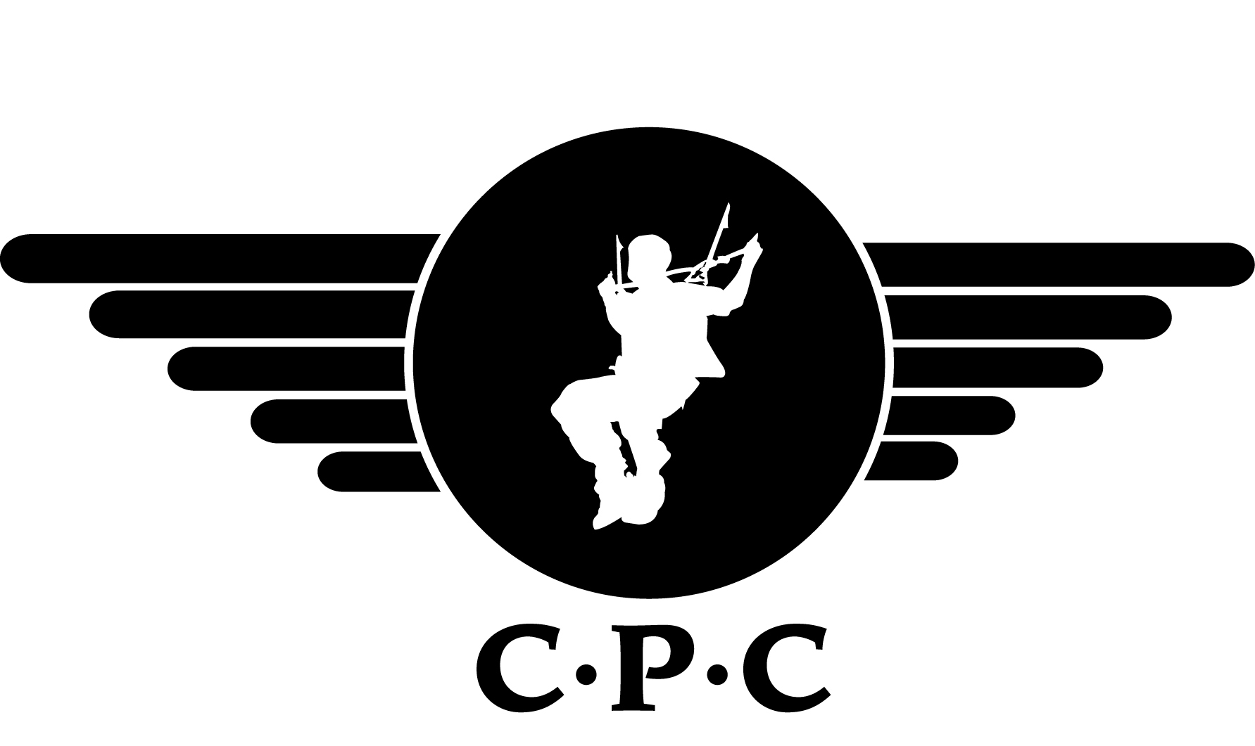

BOOKING FORM – CHSW SKYDIVE

NAME : _____________________________________________

ADDRESS : _____________________________________________

: _____________________________________________

: _____________________________________________

: ________________ POSTCODE _______________

TELEPHONE – HOME : _____________________________________________

TELEPHONE – WORK : _____________________________________________

EMAIL : _____________________________________________

If taking part through work please tell us your company :______________________________

AGE : _______________ WEIGHT: _______________ HEIGHT : ____________

I WISH TO ATTEND ON: ________________________ (day /date required)

TYPE OF DESCENT: * Charity Tandem Skydive

15st (95 Kilo) limit Depending on your height.

(If over this weight please contact the club)

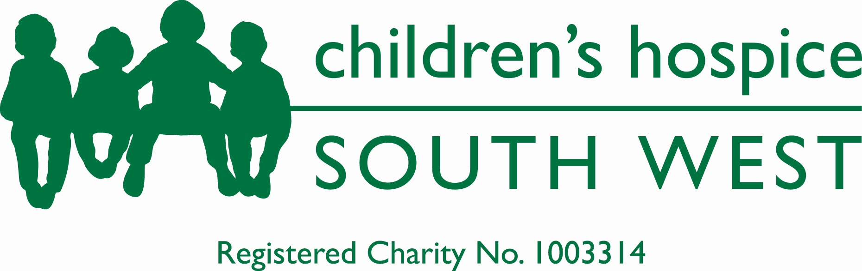
I would like to make a sponsored jump for the following charity:

*I HAVE ENCLOSED: Deposit of £50 Cheque made payable to: Cornish Parachute Club Ltd

*PLEASE DEBIT MY DEBIT CARD: (No Credit Cards)

Visa Delta /Maestro(Dom) / Solo / Electron (Issue Number:___ )

Credit Card Number:

Start Date: |  |  | /
Expiry Date: |  |  | /

* Delete as necessary. * All deposits are Non – Refundable.

